**Lab Practical #01:**

Study of basic networking commands and IP configuration.

**Practical Assignment #01:**

1. Perform and explain various networking commands listed below:
   1. ipconfig
   2. ping
   3. getmac
   4. systeminfo
   5. traceroute / tracert
   6. netstat
   7. nslookup
   8. hostname
   9. pathping
   10. arp

## ipconfig

### Description:

**The ipconfig command is a Windows command-line utility that displays and manages the IP configuration of your computer’s network interfaces.**

|  |  |  |
| --- | --- | --- |
| No. | Option | Description |
| 1 | ipconfig | Displays IP address, subnet mask, and default gateway for all adapters. |
| 2 | |  | | --- | | ipconfig /all |  |  | | --- | |  | | |  | | --- | | Shows detailed info, including DNS, MAC address, DHCP status, etc. |  |  | | --- | |  | |
| 3 | |  | | --- | | ipconfig /release |  |  | | --- | |  | | |  | | --- | | Releases the current IP address (used with DHCP). |  |  | | --- | |  | |
| 4 | |  | | --- | | ipconfig /renew |  |  | | --- | |  | | |  | | --- | | Requests a new IP address from the DHCP server. |  |  | | --- | |  | |
| 5 | |  | | --- | | ipconfig /flushdns |  |  | | --- | |  | | |  | | --- | | Clears the DNS resolver cache. |  |  | | --- | |  | |

### Implementation:

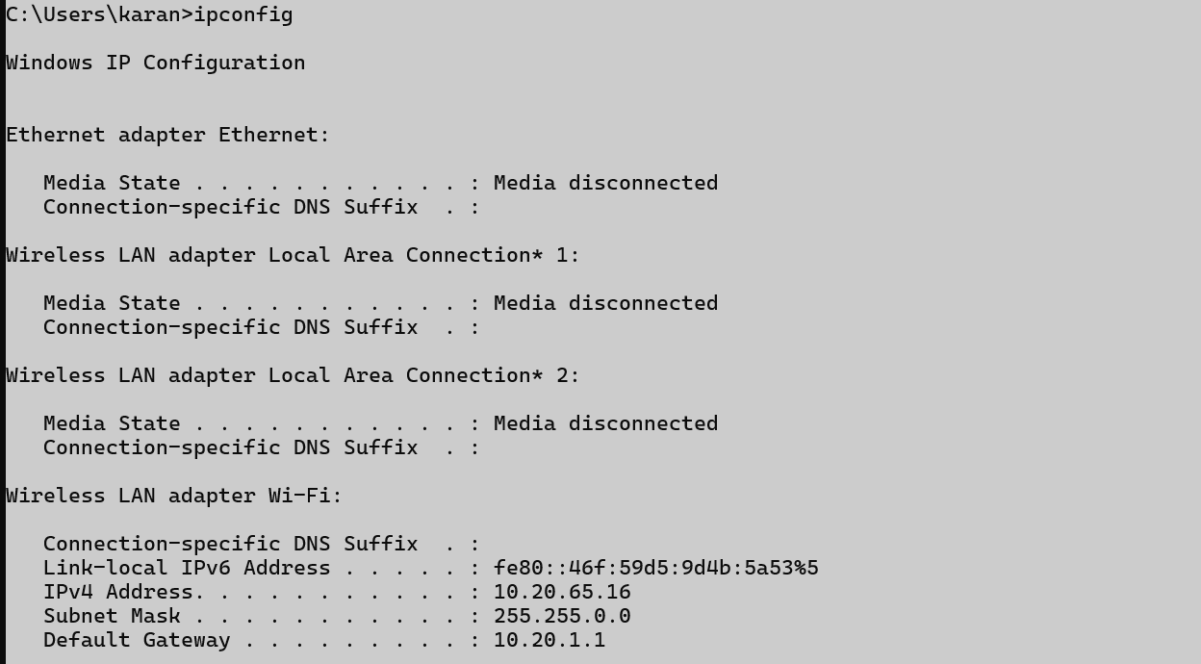

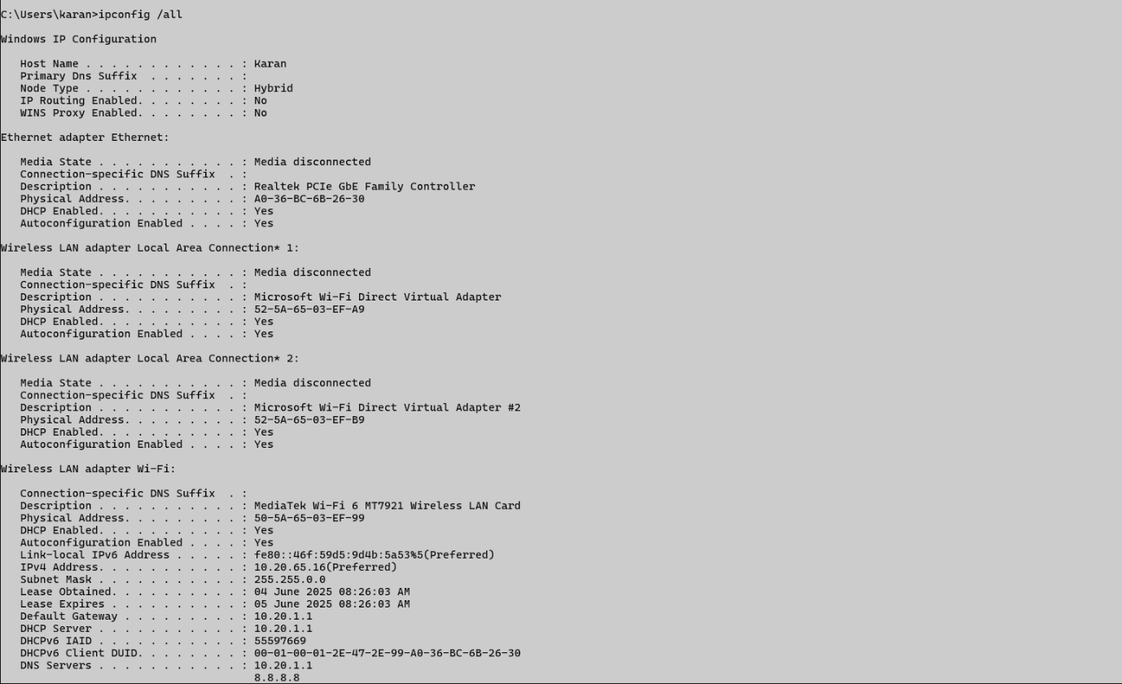

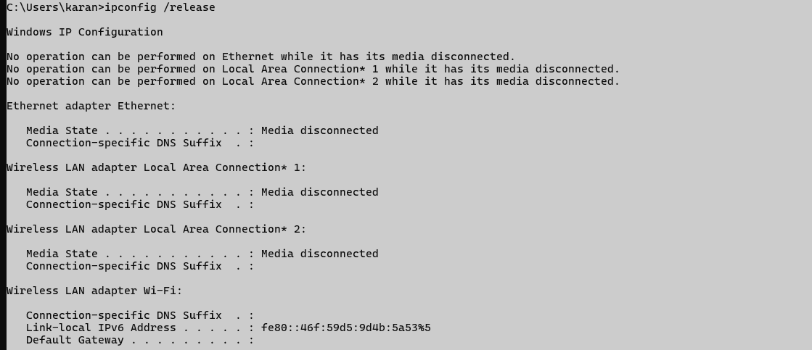

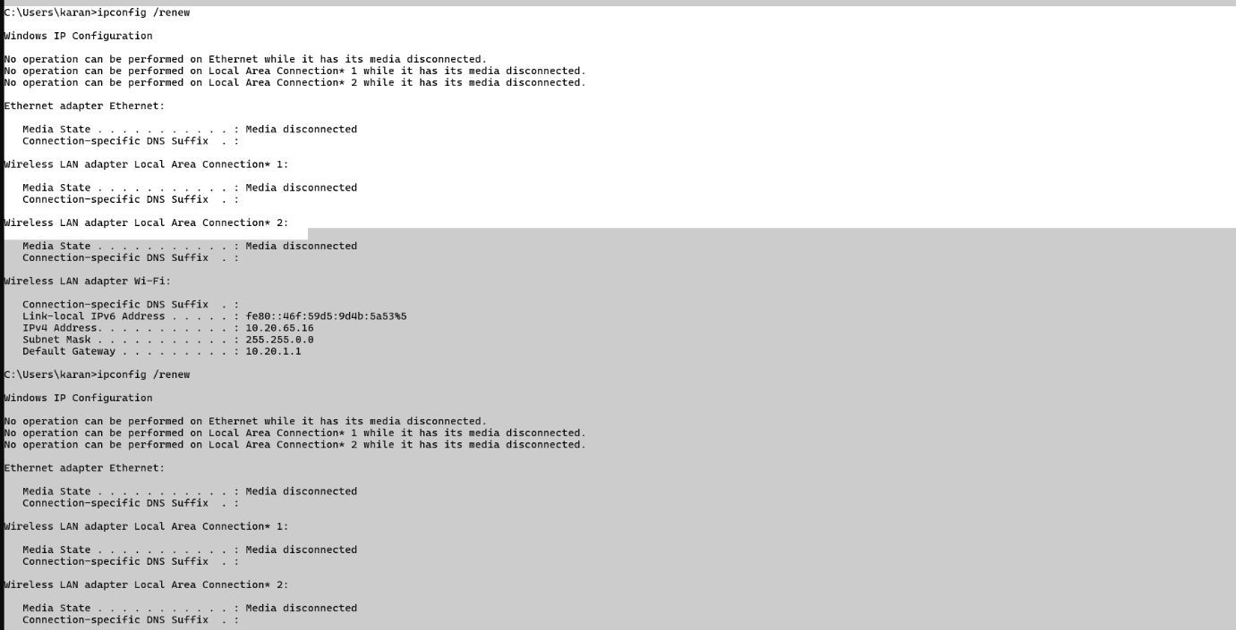



## ping

### Description:

**The ping command is a network diagnostic tool used to test connectivity between your computer and another device (like a server, website, or IP address).**

|  |  |  |
| --- | --- | --- |
| No. | Option | Description |
| 1 | ping -n 5 google.com | |  | | --- | |  |   Sends a specific number of pings. |
| 2 | |  | | --- | | ping -t host |  |  | | --- | |  | | Pings the target continuously until stopped |
| 3 | ping -l 5 darshanums.in | |  | | --- | | Sets the size (in bytes) of the ping packet. |  |  | | --- | |  | |
| 4 | ping -4 darshanums.in | |  | | --- | | Forces use of IPv4. |  |  | | --- | |  | |
| 5 | ping -6 google.com | |  | | --- | | Forces use of IPv6. |  |  | | --- | |  | |

### Implementation:

**----- Screenshot Only (Execute command on command prompt / terminal) -----**

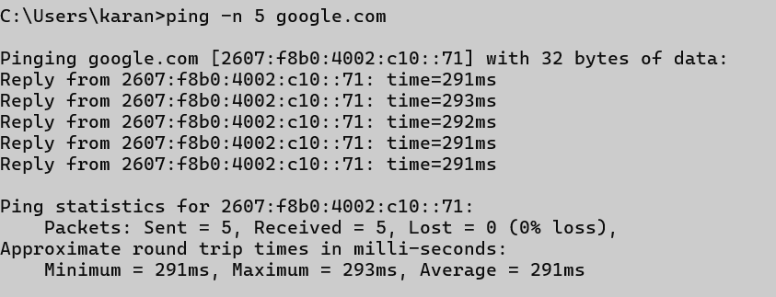

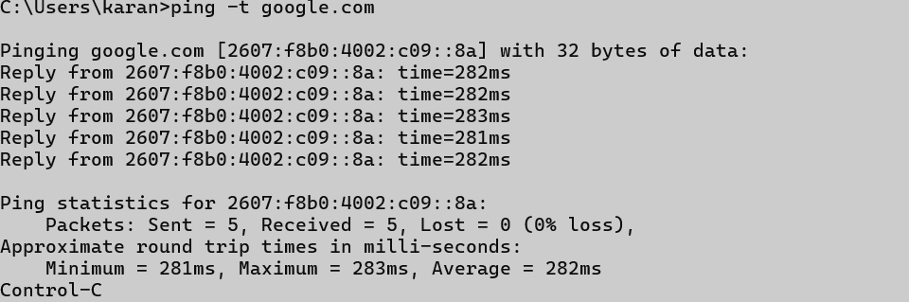

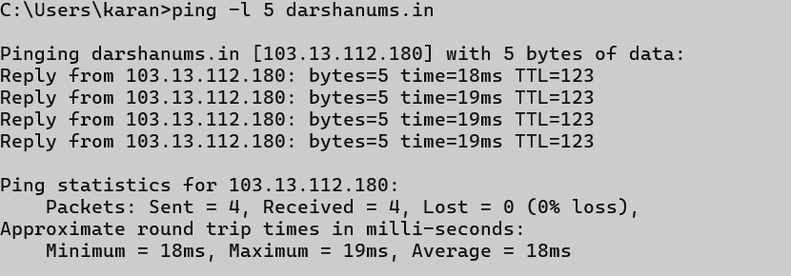

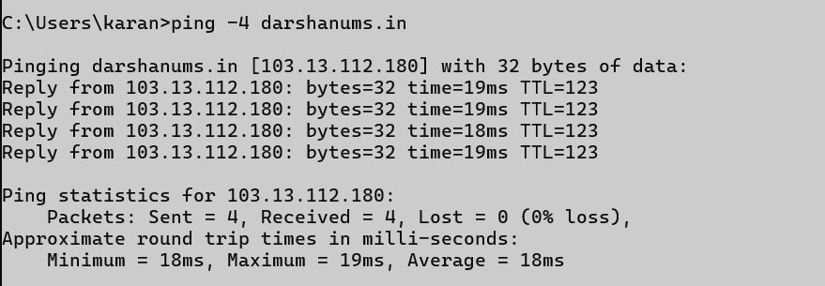

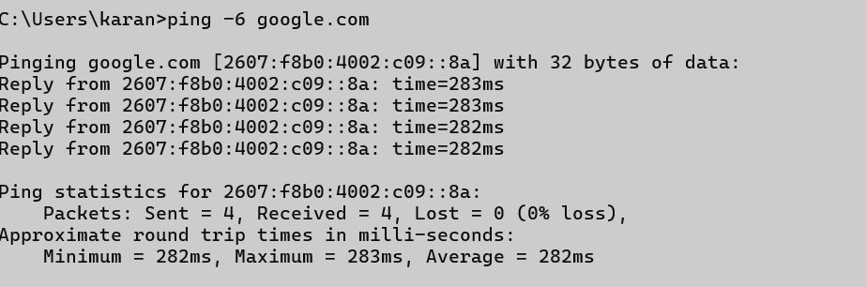

## getmac

### Description:

**The getmac command is a Windows command-line utility that displays the MAC address (Media Access Control address) of your computer's network adapters.**

|  |  |  |
| --- | --- | --- |
| No. | Option | Description |
| 1 | |  | | --- | | getmac /v |  |  | | --- | |  | | |  | | --- | | Displays verbose output (more detailed). |  |  | | --- | |  | |
| 2 | getmac /fo table | Format the output: TABLE, LIST, or CSV. Example: getmac /fo csv |
| 3 | getmac /nh | No headers in the output |

### Implementation:

**----- Screenshot Only (Execute command on command prompt / terminal) -----**

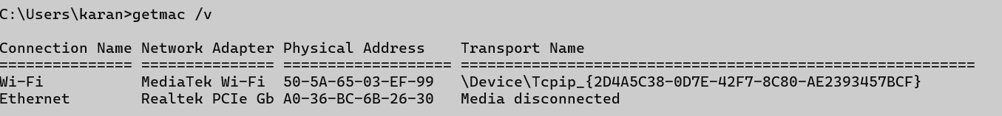

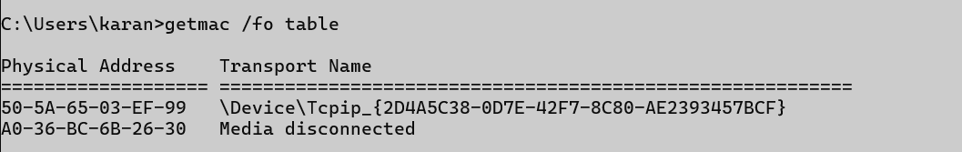



## systeminfo

### Description:

**The systeminfo command is a Windows command-line tool that displays detailed information about your computer’s hardware and software configuration.**

|  |  |  |
| --- | --- | --- |
| No. | Option | Description |
| 1 | systeminfo | This command lists a comprehensive summary of system details. |
| 2 | system /s Karan | |  | | --- | | Get info from a remote computer. |  |  | | --- | |  | |
| 3 | |  | | --- | | system /fo [format] |  |  | | --- | |  | | |  | | --- | | Output format: TABLE, LIST, or CSV. |  |  | | --- | |  | |

### Implementation:

**----- Screenshot Only (Execute command on command prompt / terminal) -----**

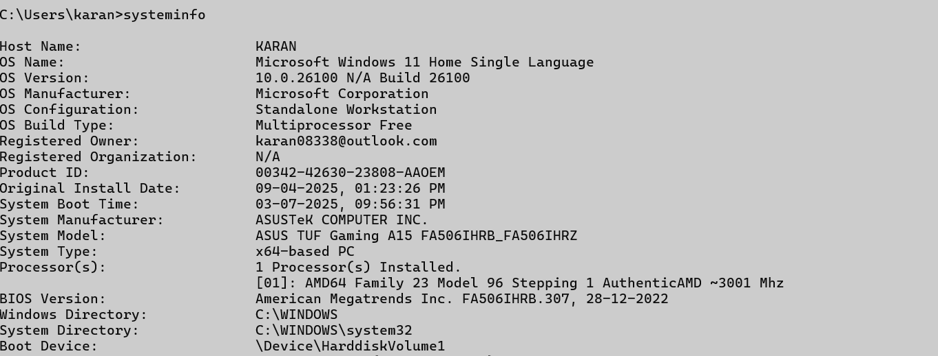

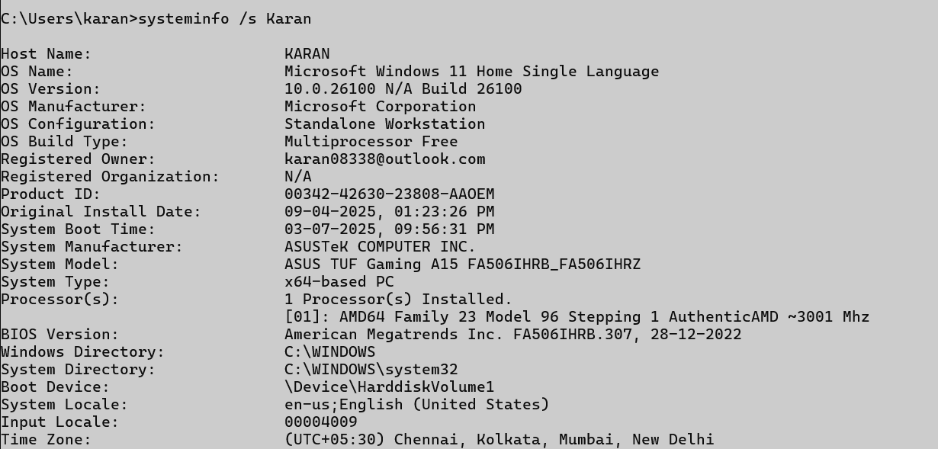

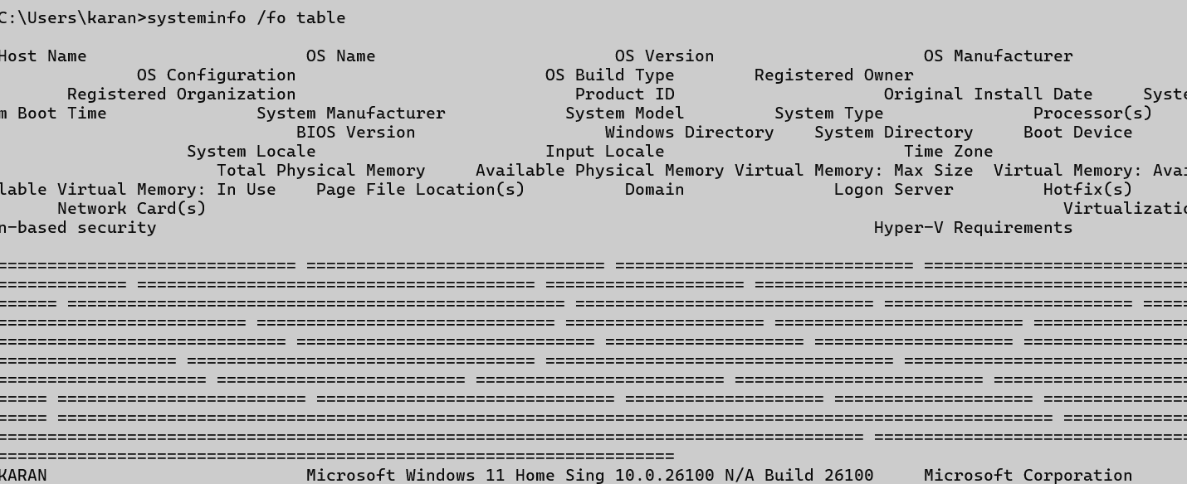

## tracert

### Description:

**Tracert command (short for trace route) is a Windows command-line tool used to trace the path that packets take from your computer to a destination host (like a website or IP address).**

|  |  |  |
| --- | --- | --- |
| No. | Option | Description |
| 1 | tacert | Diagnose where delays or failures occur in a network path. |
| 2 | tacert -d | |  | | --- | | Do not resolve IP addresses to hostnames (faster). | |
| 3 | |  | | --- | | tacert -h |   max | |  | | --- | | Set the max number of hops to search (default is 30). |  |  | | --- | |  | |
| 4 | tacert -4 google.com | |  | | --- | |  |  |  | | --- | | Ipv4 Terminal ipaddress | |

### Implementation:

**----- Screenshot Only (Execute command on command prompt / terminal) -----**

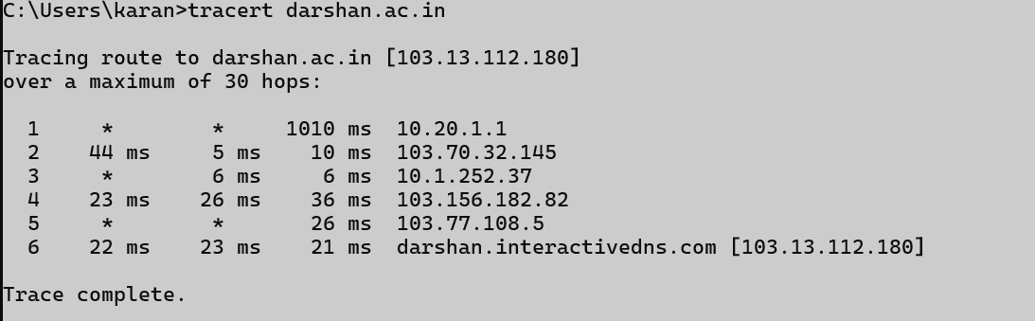

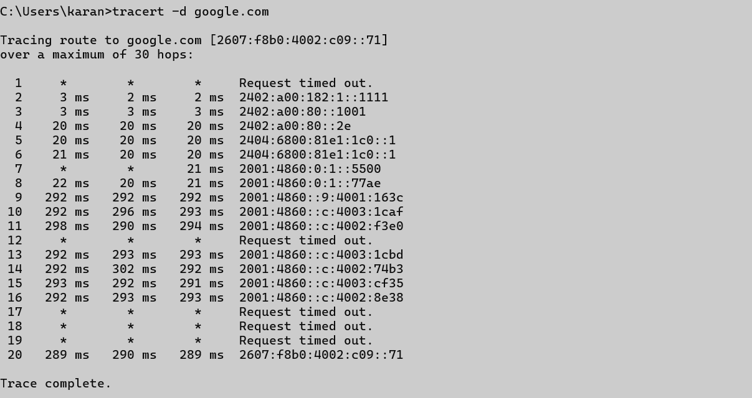

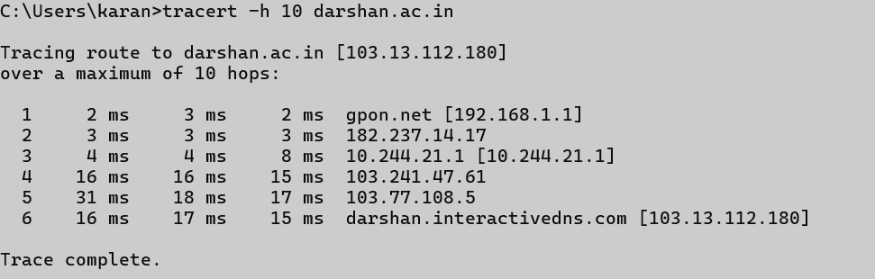



## netstat

### Description:

**The netstat command is a powerful network utility that displays network connections, routing tables, interface statistics, and more. It’s available on Windows, Linux, and macOS.**

|  |  |  |
| --- | --- | --- |
| No. | Option | Description |
| 1 | netstat | By default, it shows active TCP connections. |
| 2 | netstat - a | |  | | --- | | Show all active connections and listening ports. | |
| 3 | |  | | --- | | netstat -r | | |  | | --- | | Display the routing table. |  |  | | --- | |  | |
| 4 | |  | | --- | | netstat -s |  |  | | --- | |  | | |  | | --- | | Show per-protocol statistics. |  |  | | --- | |  | |
| 5 | netstat -e | Show Ethernet statistics |

### Implementation:

**----- Screenshot Only (Execute command on command prompt / terminal) -----**



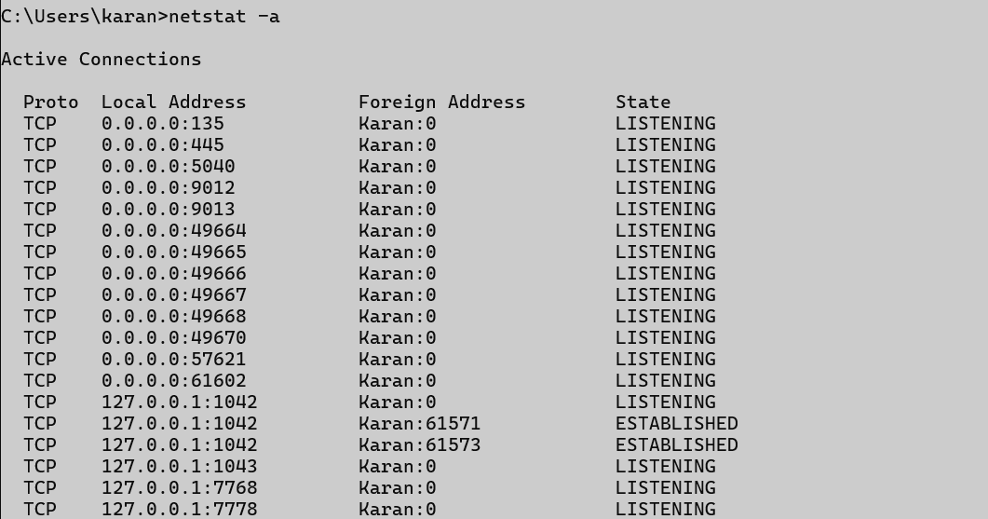



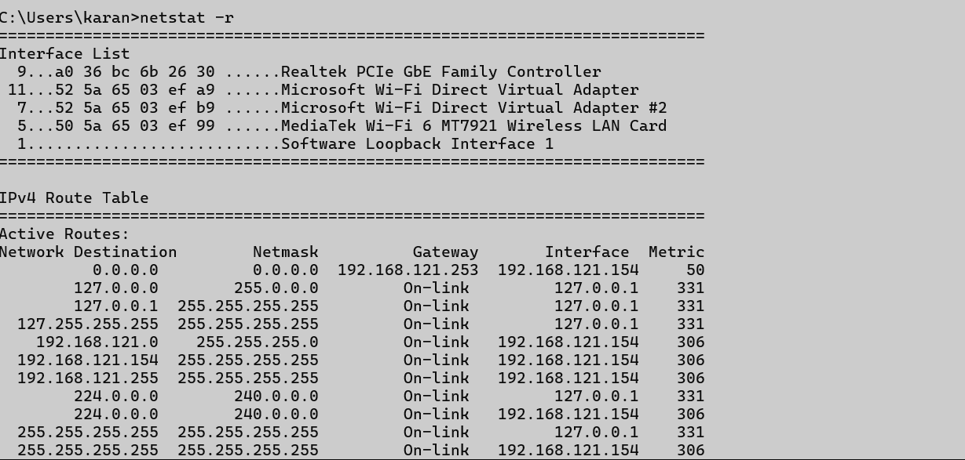

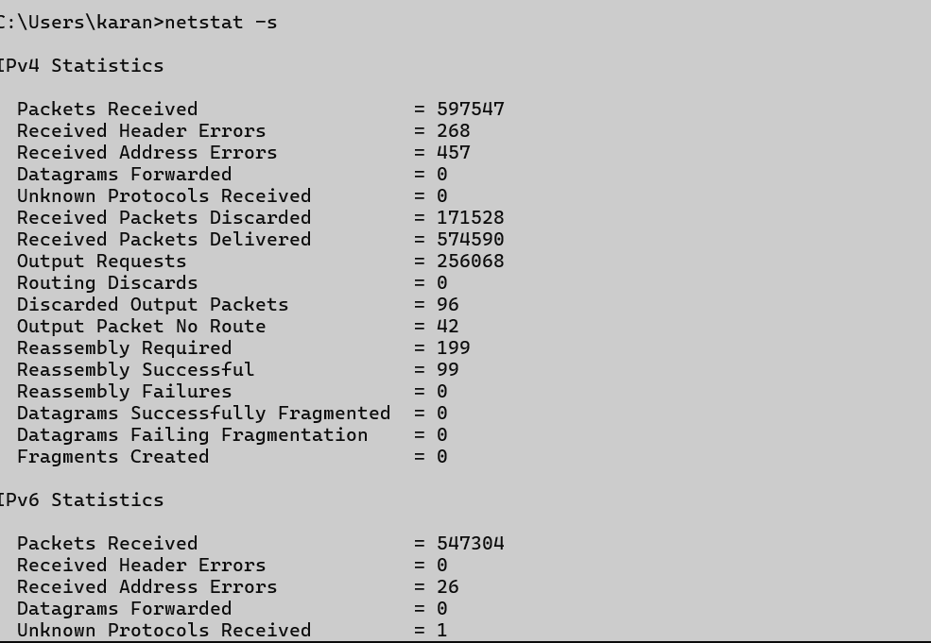

## nslookup

### Description:

**The nslookup command is a network tool used to query Domain Name System (DNS) servers. It helps you find the IP address associated with a domain name or vice versa.**

|  |  |  |
| --- | --- | --- |
| No. | Option | Description |
| 1 | nslookup | |  | | --- | | Starts interactive mode where you can type multiple queries. |  |  | | --- | |  | |
| 2 | |  | | --- | | server DNS server |  |  | | --- | |  | | |  | | --- | | Use a specific DNS server for queries | |
| 3 | |  | | --- | | set type=[record type] | | |  | | --- | | Query specific DNS record types |  |  | | --- | |  | |

### Implementation:

**----- Screenshot Only (Execute command on command prompt / terminal) -----**



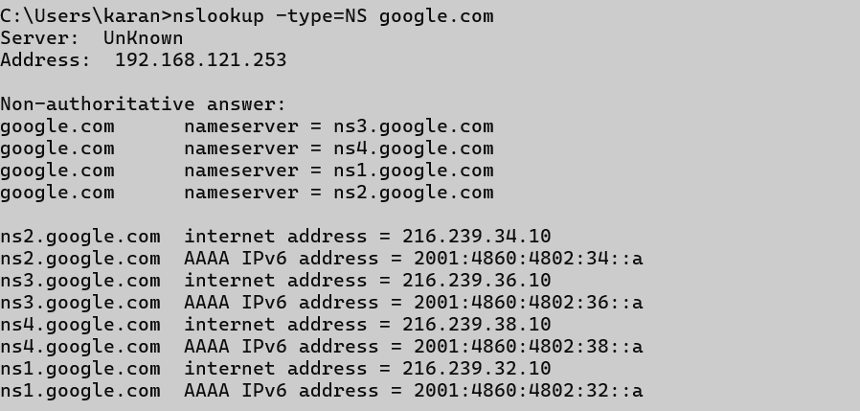

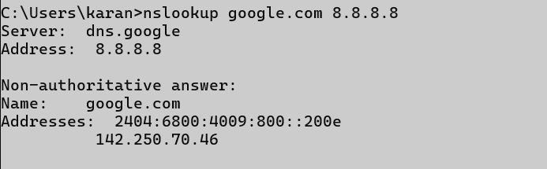

## hostname

### Description:

**The hostname command is a simple utility used to display or set the hostname of a computer.**

|  |  |  |
| --- | --- | --- |
| No. | Option | Description |
| 1 | hostname | This displays the name of the computer (its network name). |

### Implementation:

**----- Screenshot Only (Execute command on command prompt / terminal) -----**



## pathping

### Description:

**The pathping command is a Windows command-line utility that combines the functionality of ping and tracert (trace route).**

|  |  |  |
| --- | --- | --- |
| No. | Option | Description |
| 1 | pathping - n | Don’t resolve hostnames (show only IPs — faster). |
| 2 | pathping -h max | Maximum number of hops to search |
| 3. | pathping -g hostlist | |  | | --- | | Loose source route along the given hosts. |  |  | | --- | |  | |
| 4. | pathping -p period | |  | | --- | | Wait time (in ms) between pings (default is 250 ms). |  |  | | --- | |  | |
| 5. | pathping -q 5 | Number of queries per hop (default is 100). |

### Implementation:

**----- Screenshot Only (Execute command on command prompt / terminal) -----**

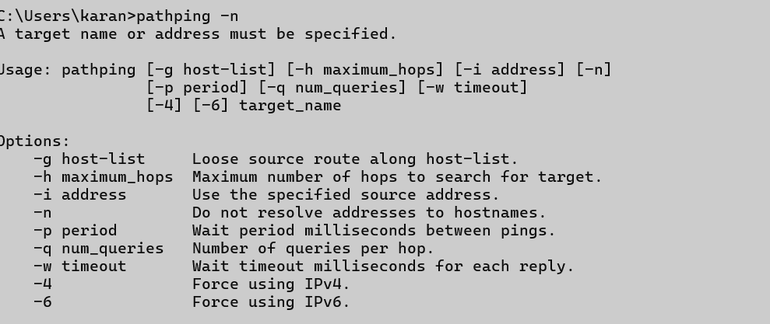

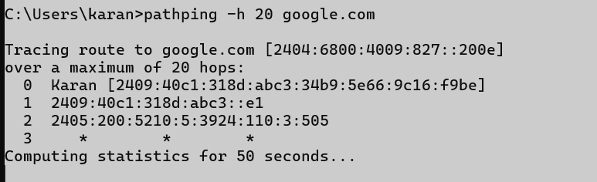

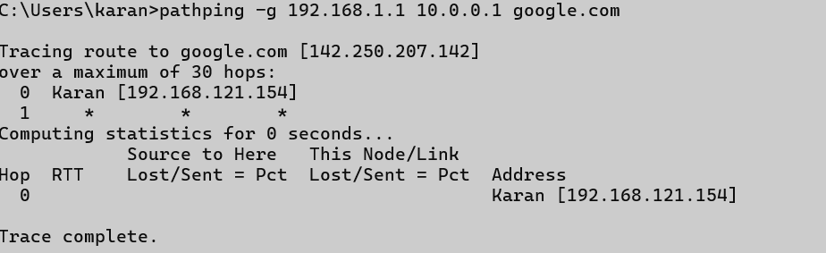

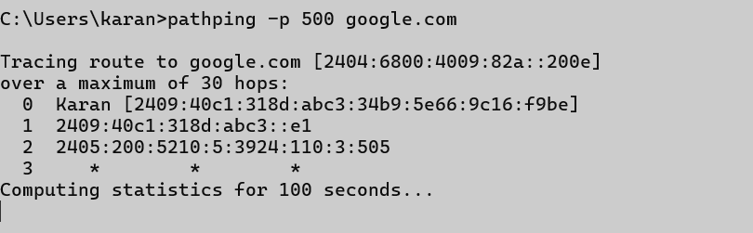

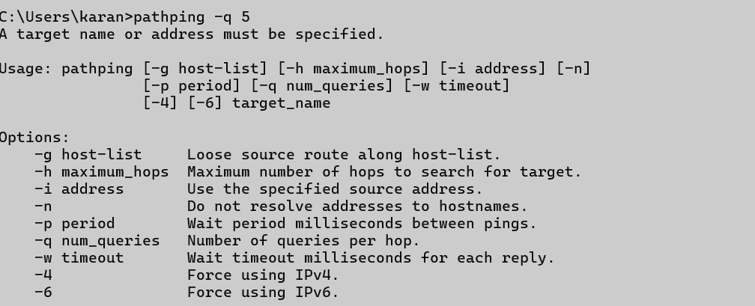

## arp

### Description:

**The arp command is used to view and manage the ARP (Address Resolution Protocol) cache, which maps IP addresses to MAC (physical) addresses on a local network.**

|  |  |  |
| --- | --- | --- |
| No. | Option | Description |
| 1 | -a | |  | | --- | | Displays the current ARP entries |  |  | | --- | |  | |
| 2 | -g | Same as globaly |
| 3. | -d ipaddress | |  |  | | --- | --- | | |  | | --- | | Deletes the ARP entry for the specified IP address | |  |  | | --- | |  | |
| 4. | -s ipadress mac address | Adds a static ARP entry |

### Implementation:

**----- Screenshot Only (Execute command on command prompt / terminal) -----**





